SQL Database Design Example
Author: Olivia Rueschhoff
This database is made up of entirely fictional data with the whole purpose of showcasing my ability to build a working database with multiple tables.

- ER-Diagram and Relationships Explained
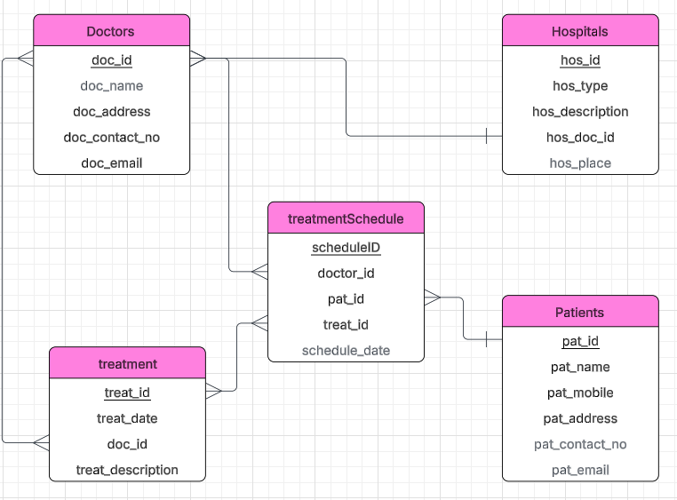
Within the hospital database we can see that each hospital has many doctors (1:M). Each treatmentSchedule goes to one patient, but a patient could have multiple treatmentSchedules from multiple hospital visits (1:M). Within treatmentSchedule, we will have multiple doctors working on multiple treatmentSchedules (M:N), and multiple doctors will be able to conduct multiple different treatments (M:N). Lastly, we can have multiple treatments being done on multiple different treatmentSchedules (M:N).
- Populating the Tables
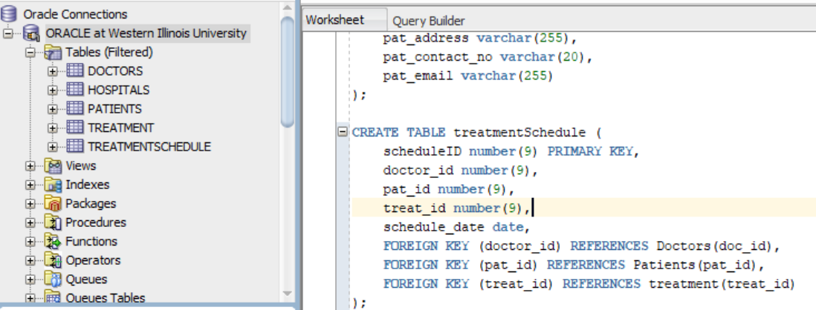
I have created all 5 tables, now I just need to use Mockaroo to fill the tables, which is shown for all 5 entities below. Note: with my excel knowledge and the need to make sure Primary Key data remained consistent, I chose to save the mock data as csv files and import them into sql developer.
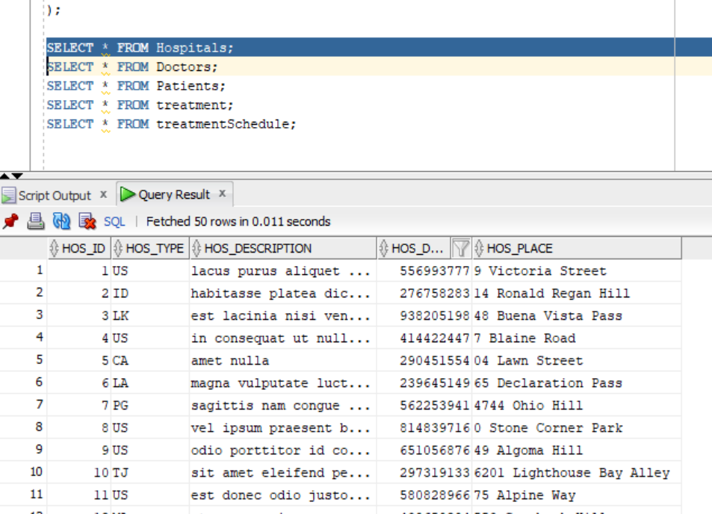
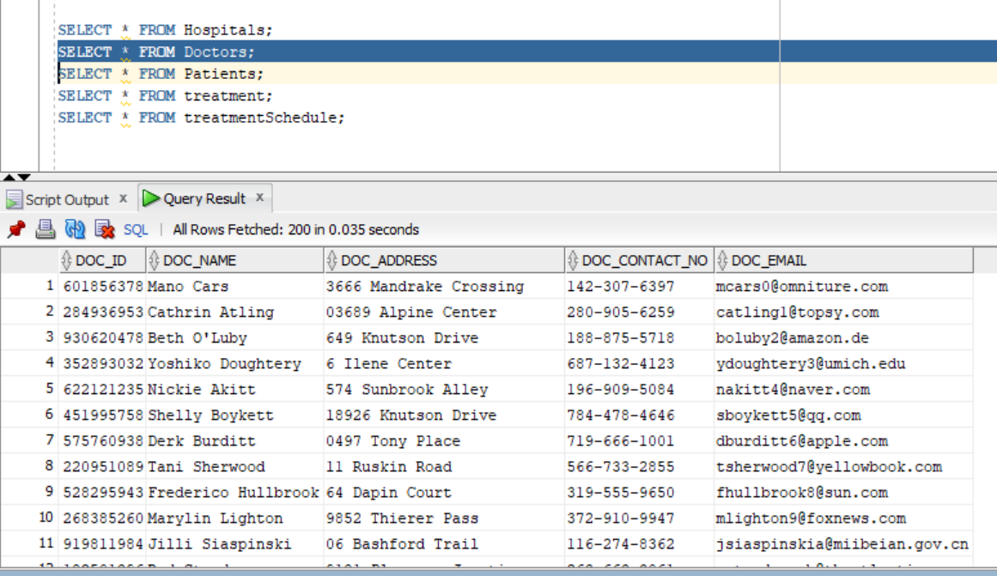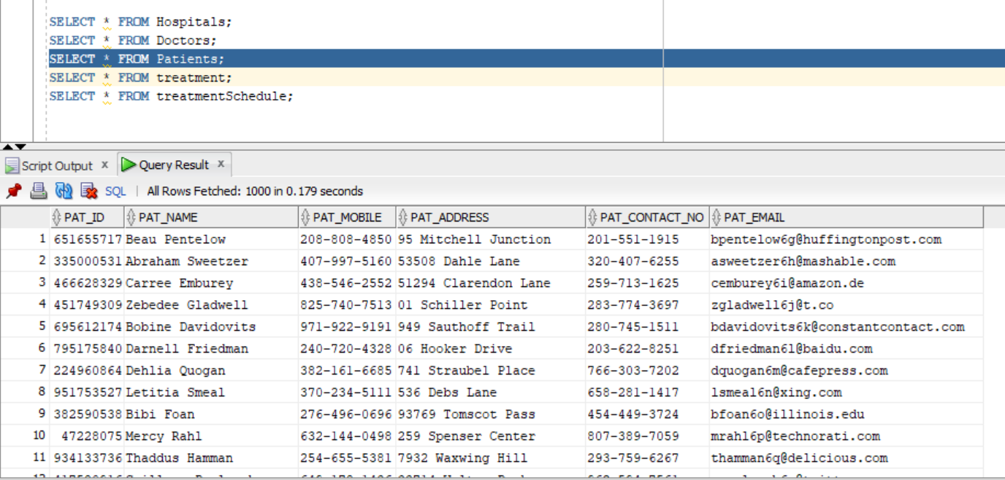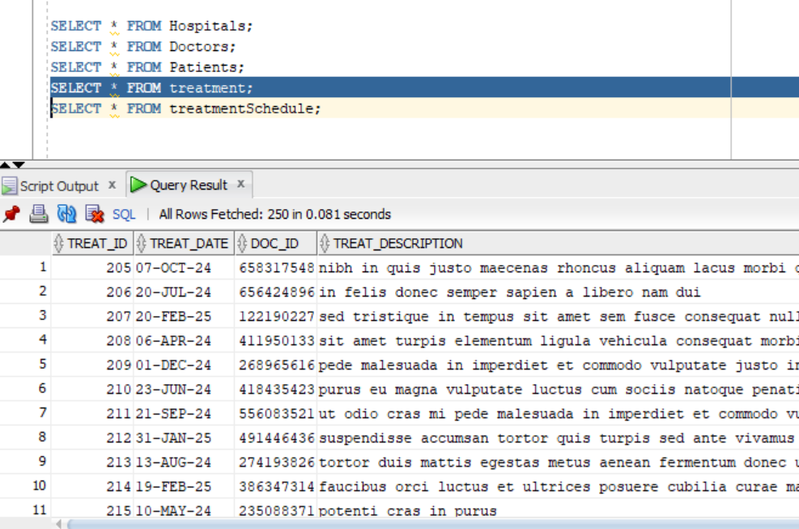
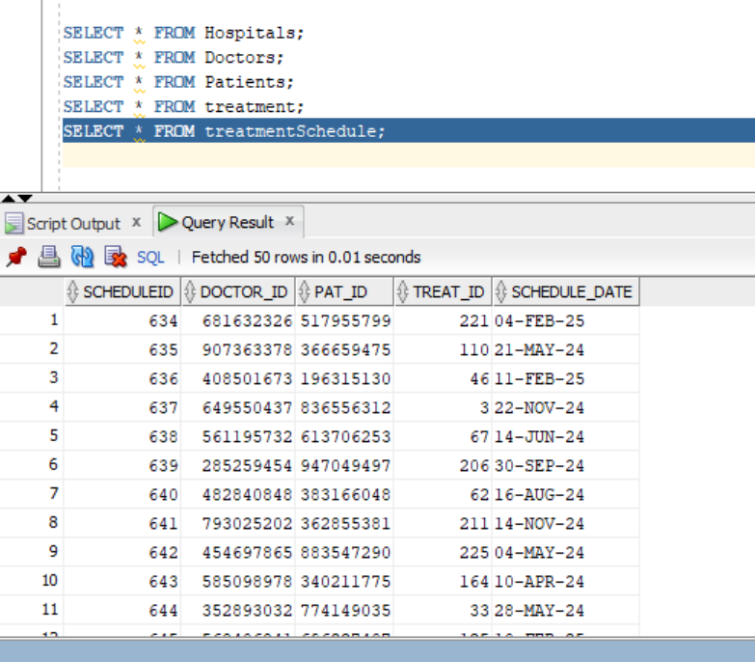
- Indexing
When you declare a primary key in Oracle, it automatically creates a B-tree index on that column. So, because hos_id is set as a Primary Key as seen below, it is a B-tree index.
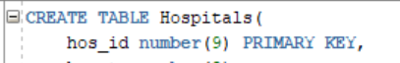
And once again, Oracle’s defaults to B-trees for indexing so in order to create a secondary B-tree on Doctor names and patient names, we just need to create a secondary index and it will automatically by B-tree. 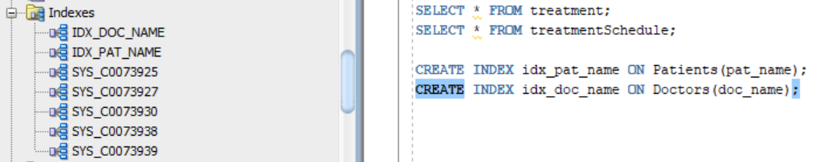

- Creating Relevant Views
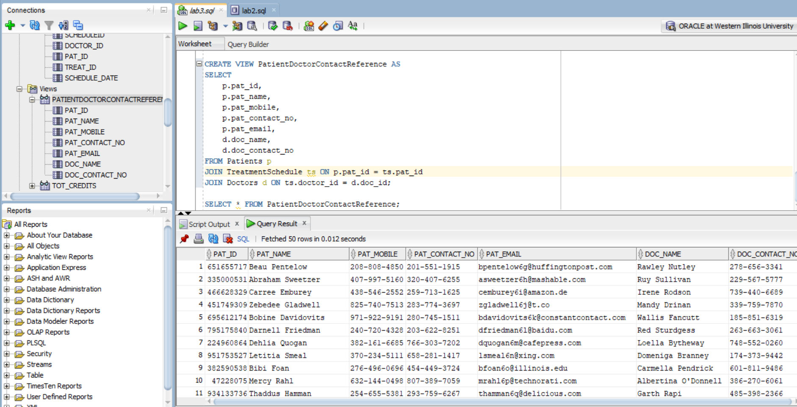
This is the view of Doctor Patient Contract Reference including the patients contact number, mobile number, and email so that the person scheduling the appointment can get ahold of the patient. And the Doctors contact number so that they can let the doctor know they have an appointment scheduled then. The medical assistant in charge of scheduling the appointments does not need to see any additional attributes as things such as Doctor ID would not be needed to contact the patient. However, patient ID and patient name are included so the assistant can make sure they are contacting the correct patient.

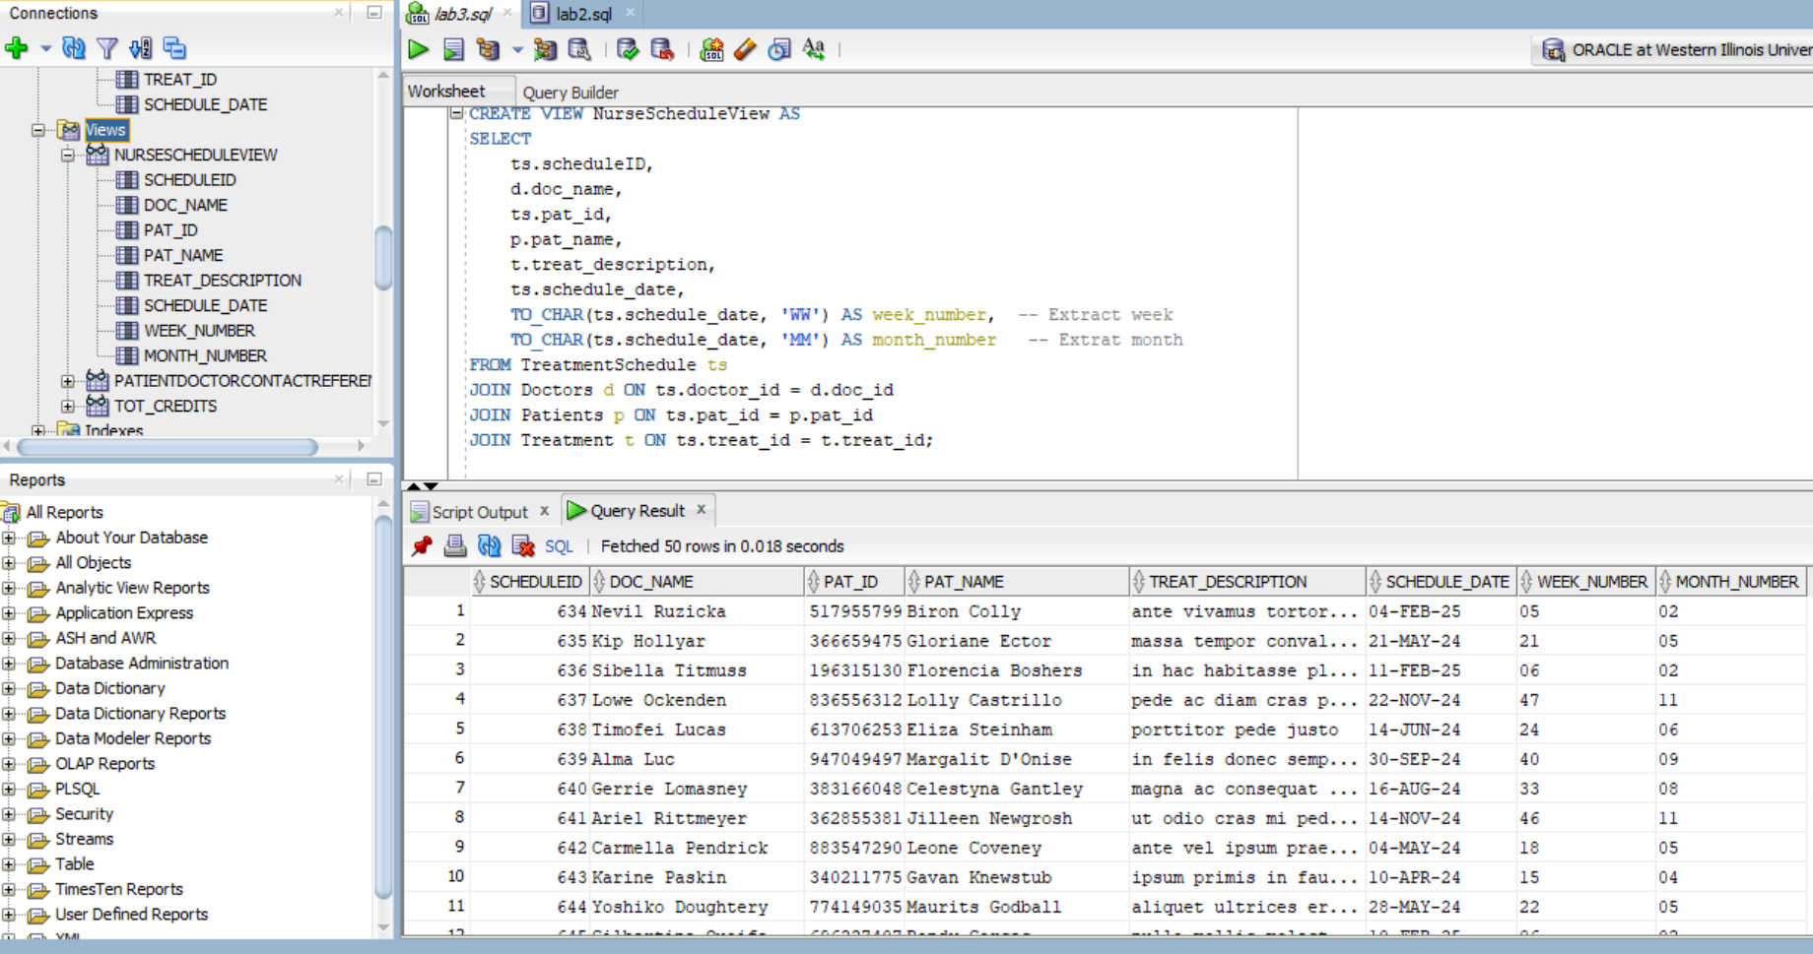
This is the view of Nurse Schedule. The nurse can look at this to see what doctor, patient, and treatment will be taking place on what day. Because of the extracted week and month, the nurse can sort the data base to get a weekly or monthly view of the schedule.

- Java Database Integration
The Java file named Java_Database_Integration demonstrates the ability to connect SQL databases to other coding languages so that individuals who may not know SQL can still update, add to, and delete data from a table. I made it so that my Java code could ideally be easily accessible to anyone who just runs the code as it spits out straight forward instructions on how to change the tables. It is just a brief Demo so it only effects 2 o the 5 tables, but as it can change patient or doctor information then it would likely be used by a reception worker in the real world application of this simulation.

